Natural Readers
Online platform where documents can be uploaded to have them read aloud.

- Click this link or copy and paste the address into web search bar:
https://www.naturalreaders.com/
- Click blue button, bottom left – Go To Online reader
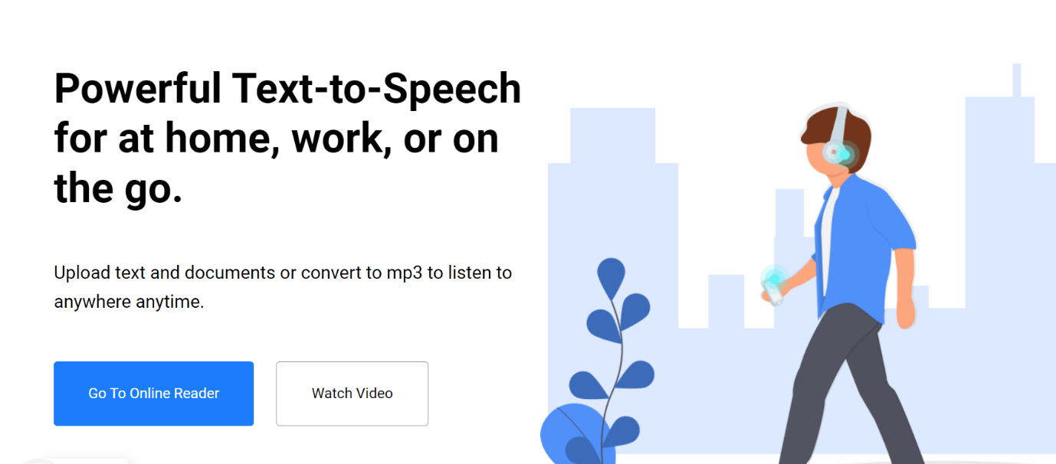
- Create account (It will normally log you in if you save log in after this occasion)

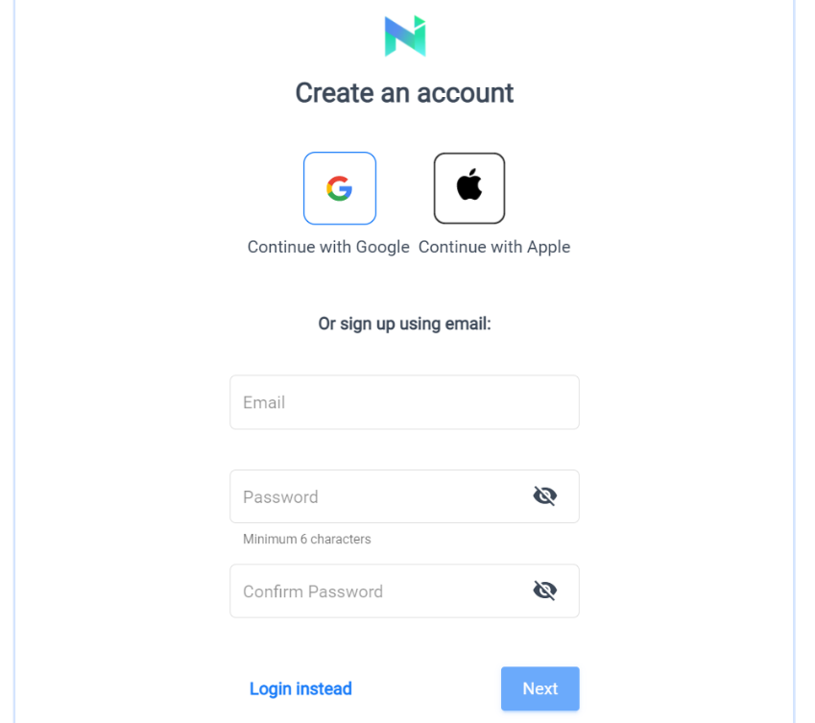

- Verify your email account

- Add to chrome(edge is same link) if you would like (optional but can be used with online ebooks)
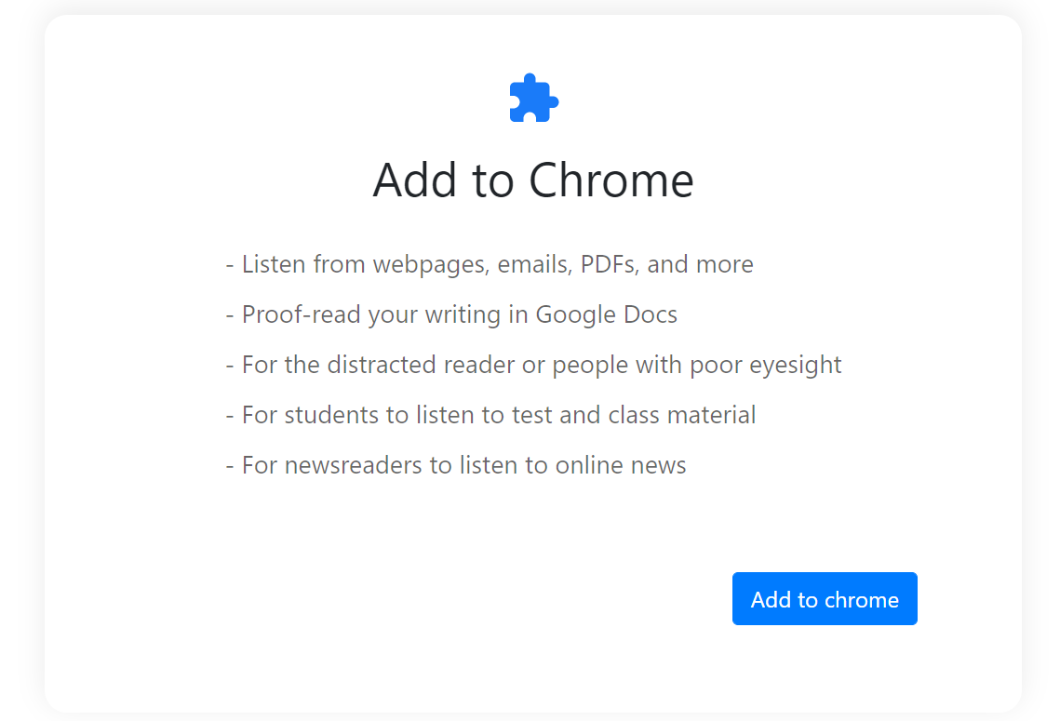
- This is what it looks like
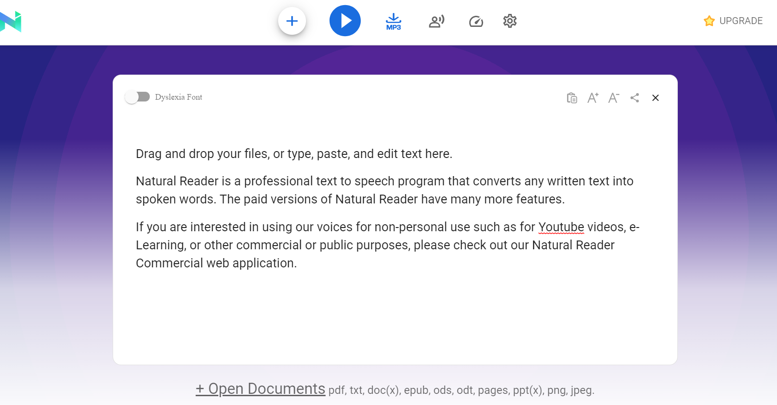
- Upload documents you want read

- Click play and pause

- You can change the type of voice, and speed of reading using the top buttons

- You can download any docs you have uploaded into an MP3 file

Plugin
Sits in top right hand of search bar
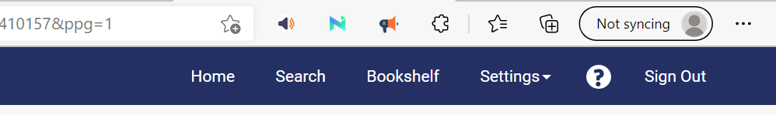

- Click to open in webpage you want to use
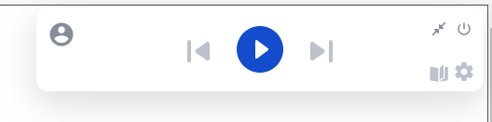

- Click in page you want to start reading and press play
- Change voice and speed by clicking settings
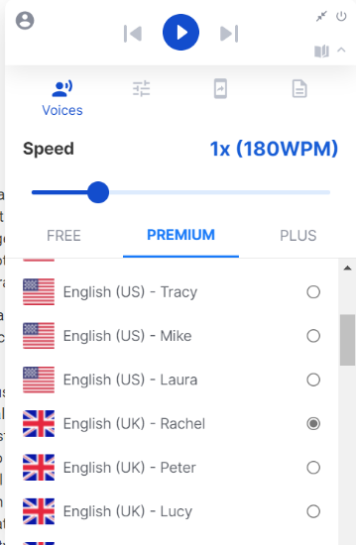
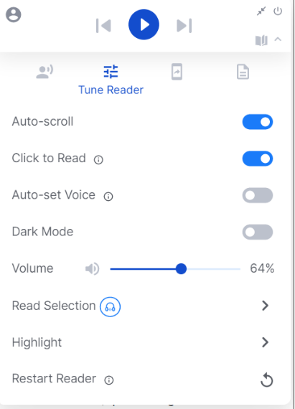

- Click immersive reader to place into an easier to read font and format
